Distribution System Analysis Subcommittee

IEEE Wye-Delta Center Tapped Transformer Test Feeder

Data and Solutions

Transformer Connections
      - Ungrounded Wye-Delta
      - Grounded Wye-Delta
      - “Leading” Open Wye- Delta
      - “Lagging” Open Wye-Delta

November 2004
IEEE Four-Wire Delta Test Feeder

The system to be used in testing four wire delta transformer models is shown in Figure 1. This system is used to model the following transformer connections:
- Ungrounded wye-delta
- Grounded wye-delta
- Leading open wye-open delta
- Lagging open wye-open delta
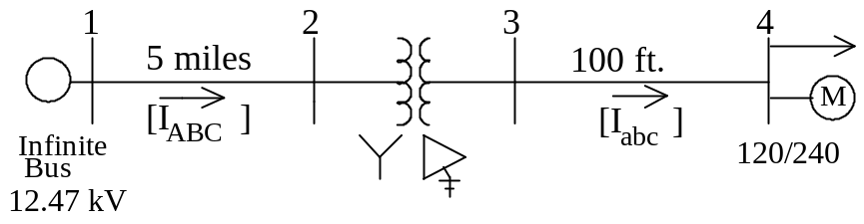
Figure 1 – Four Wire Delta Test Feeder

Three-Phase Circuit:
The three-phase circuit to be analyzed for the ungrounded wye-delta connection is shown in Figure 2. The grounded wye-delta connection will have a connection from the primary transformer neutral to the distribution line grounded neutral. The “leading” open wye – open delta connection will ground the transformer primary neutral and remove the transformer on phase C. The “lagging” open wye – open delta connection will remove the transformer on phase B from the original connection.

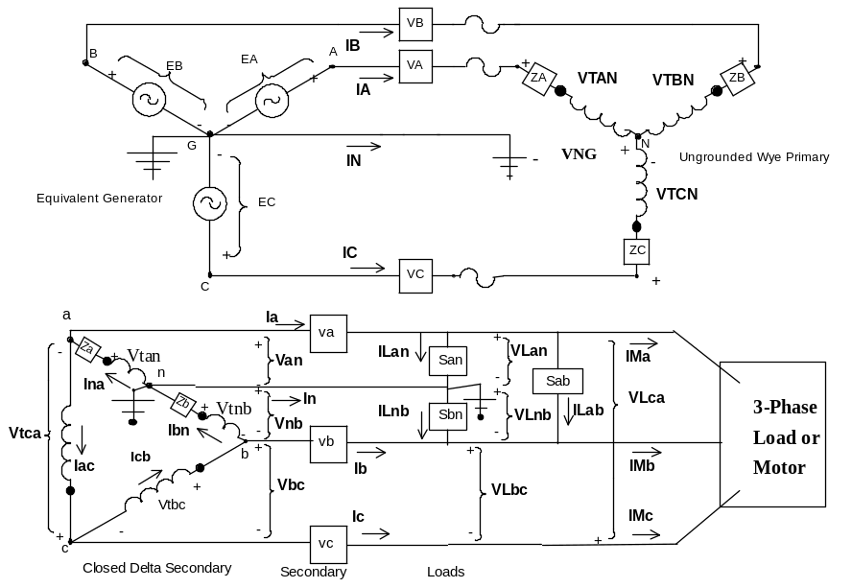
Figure 2 – Three-Phase Circuit

Equivalent Source
Balanced line-to-ground voltages of 7200 volts with abc rotation.

Primary Line:
The primary line will be constructed using the pole configuration shown in Figure 3.
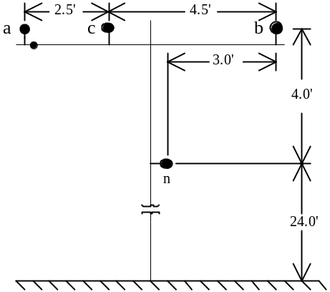
Figure 3 – Pole Configuration

Phase Conductors: 556,500 26/7 ACSR
GMR = 0.0313 ft., Resistance = 0.1859 Ω/mile, Diameter = 0.927 inch

Neutral Conductor: 4/0 6/1 ACSR
GMR = 0.00814 ft., Resistance = 0.592 Ω/mile, Diameter = 0.563 inch

Length of line = 5 miles
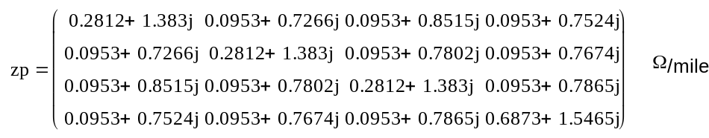
Primitive four -wire impedance matrix:

Kron reduced equivalent three-wire impedance matrix:

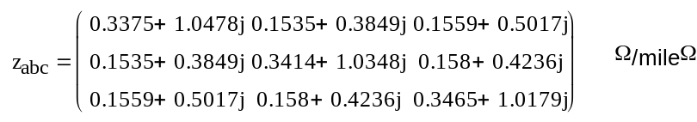
Secondary Line:
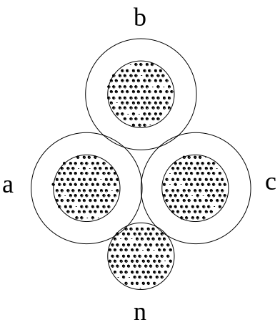The secondary line is quadraplex cable as shown in Figure 4.

Figure 4 – Quadraplex Cable

Phase Conductor: 4/0 AA
GMR = 0.0158 ft., Resistance = 0.484 Ω/mile, Diameter = 0.522 inch

Neutral Conductor: 4/0 6/1 ACSR
GMR = 0.00814 ft., Resistance = 0.592 Ω/mile, Diameter = 0.563 inch

Insulation Thickness = 0.2 inch
Length of Secondary = 100 ft.

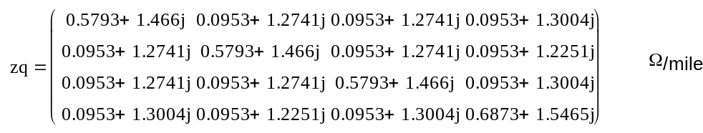
Four Wire Impedance Matrix:

Kron Reduced Equivalent Three-Wire Impedance Matrix:

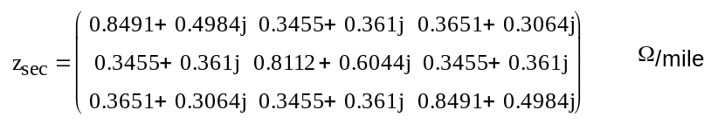

Transformer Data
Power Transformers Phase A: 25 kVA, 7200-120/240, Z_{P} = 0.012 + j0.017 per-unit

Lighting Transformers Phase B &C: 10 kVA, 7200-120/240, Z_{L} =0.016 + j0.014 per-unit

For an interlaced lighting transformer:

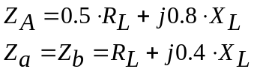 per-unit

Impedances in Ohms per the circuit diagram of Figure 5:

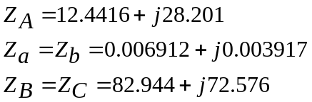 Ohms

The connection diagram for the three transformers connected in ungrounded wye-delta is shown in Figure 5.

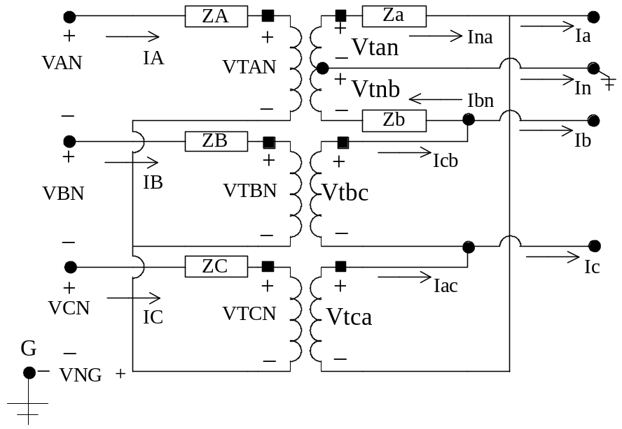
Figure 5 – Transformer Connection Diagram

Load Data
Three-Phase Induction Motor:

25 Hp, 240 volt
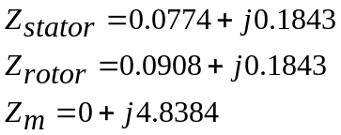 Ohms
Slip = 0.035

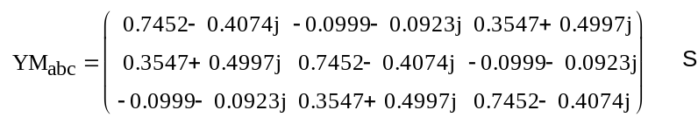
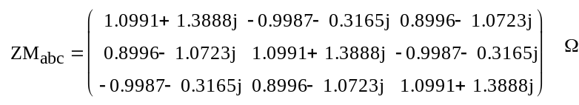
Three-phase motor admittance and impedance matrices for slip = 0.035

NEMA Voltage and Current Unbalance Equation:

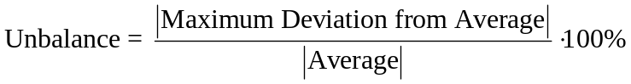

Lighting Loads:

SL_{an} = 3 kVA at 0.95 lagging power factor

SL_{bn} = 5 kVA at 0.85 lagging power factor

SL_{ab} = 10 kVA at 0.90 lagging power factor

Ungrounded Wye-Delta Solution

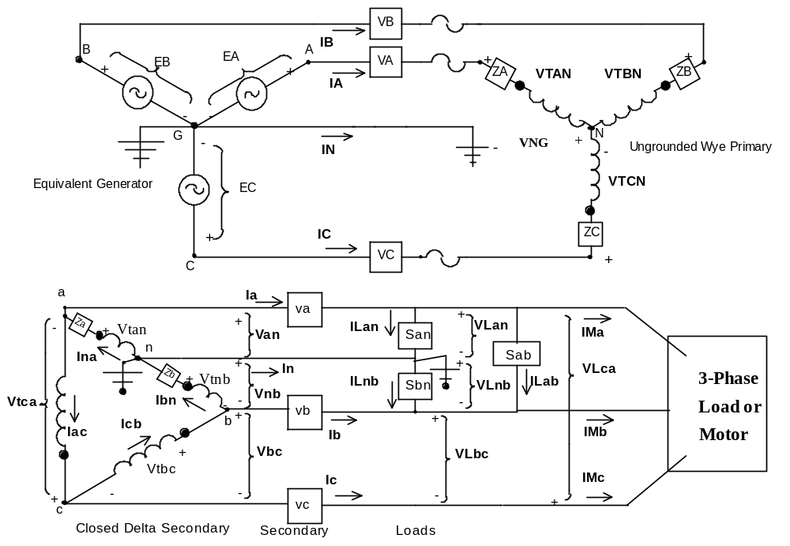

Source LG Voltages Source LL Voltages

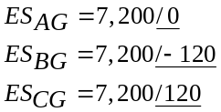 V 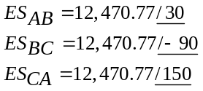 V

Primary Line Voltage Drops End of Line LG Voltages

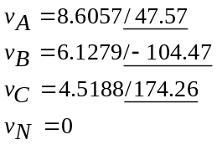 V 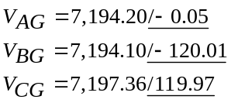

Transformer Primary LN Voltages Transformer Primary LL Voltages

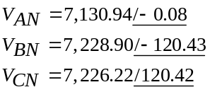 V 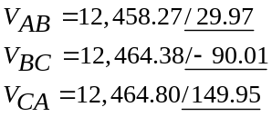V

Neutral to Ground Voltage at Transformer Primary

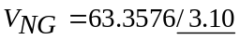 V

Primary Windings Ideal Voltages Primary Line, Neutral and Ground Currents

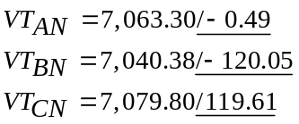 V 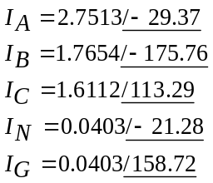 A

Transformer Secondary Windings Ideal Voltages Transformer Secondary Terminal Voltages

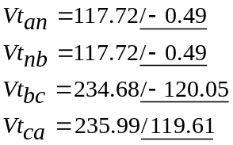 A 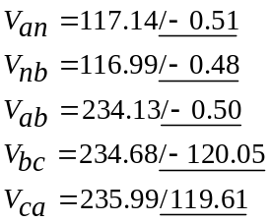 V

Transformer Secondary Winding Currents Secondary Line, Neutral and Ground Currents

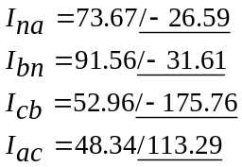 A 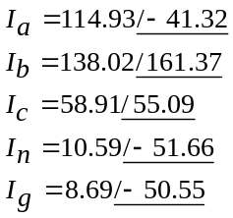 A

Secondary Line Voltage Drops Single-Phase Load Voltages

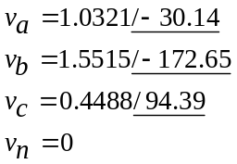 V 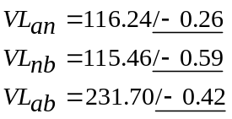 V

Single-Phase Load Currents Single-Phase Complex Powers
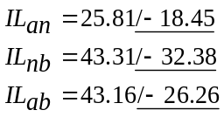 A 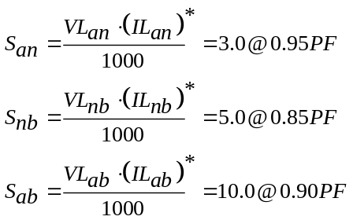 kVA
Motor LL Voltages Motor Line Currents

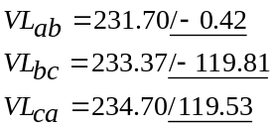 V 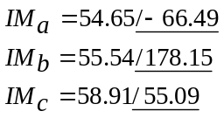 A
Transformer Operating kVAs
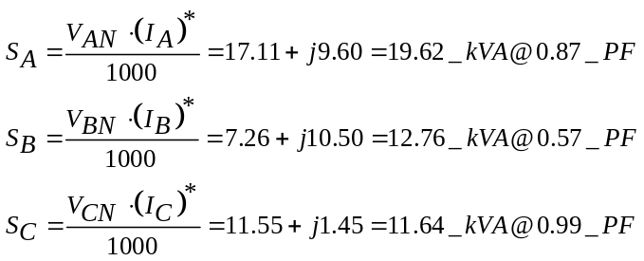

INDUCTION MOTOR ANALYSIS

Stator Input Complex Power Rotor Currents
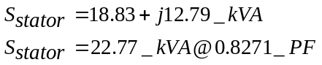 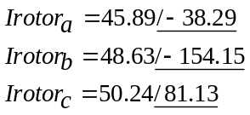 A

Losses Converted Shaft Power
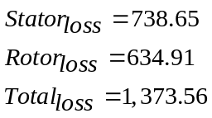 W 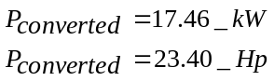 kW

NEMA Unbalances

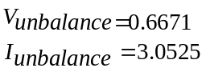 % 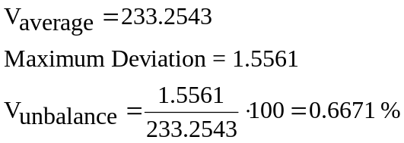

Grounded Wye-Delta Solution

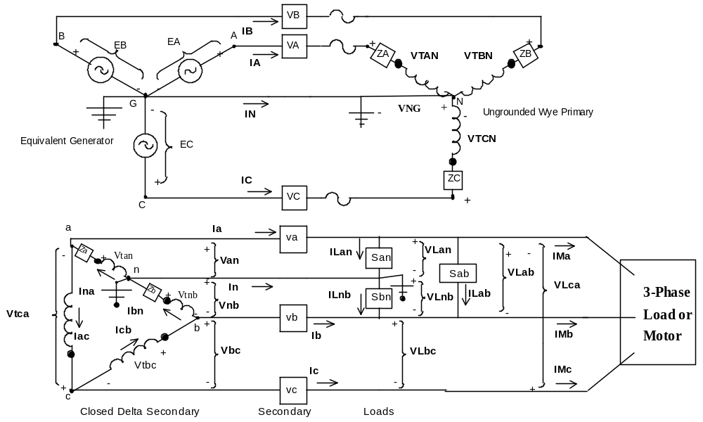

Source LG Voltages Source LL Voltages

V V

Primary Line Voltage Drops End of Line LG Voltages

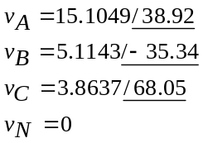 V 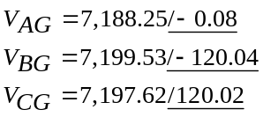 V

Transformer Primary LN Voltages Transformer Primary LL Voltages

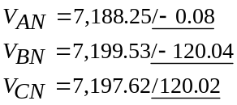 V 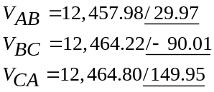V

Neutral to Ground Voltage at Transformer Primary

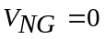 V

Primary Windings Ideal Voltages Primary Line, Neutral and Ground Currents

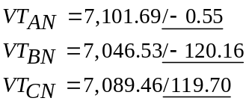 V 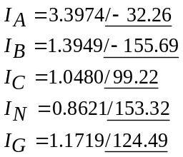 A

Transformer Secondary Windings Ideal Voltages Transformer Secondary Terminal Voltages

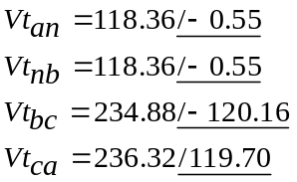 A 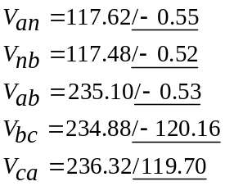 V

Transformer Secondary Winding Currents Secondary Line, Neutral and Ground Currents

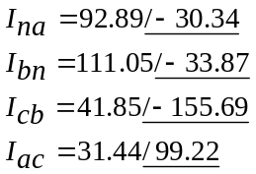 A 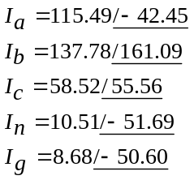 A

Secondary Line Voltage Drops Single-Phase Load Voltages

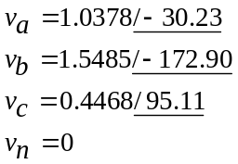 V 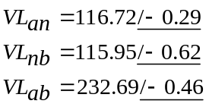 V

Single-Phase Load Currents Single-Phase Complex Powers
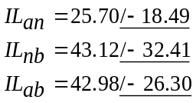 A kVA

Motor LL Voltages Motor Line Currents

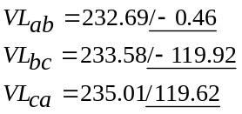 V 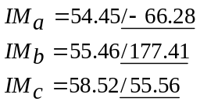 A

Transformer Operating kVAs

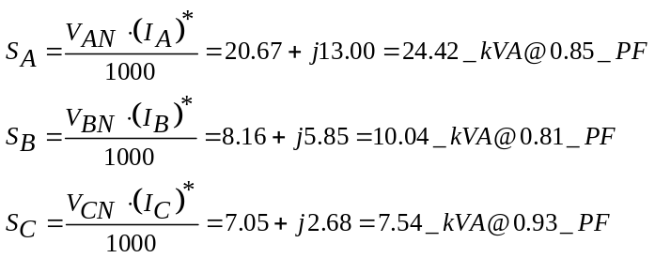

INDUCTION MOTOR ANALYSIS

Stotor Input Complex Power Rotor Currents

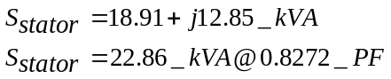 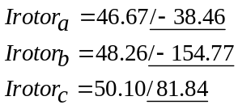 A
Losses Converted Shaft Power

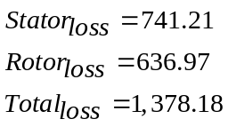 W 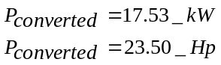 kW

NEMA Unbalances

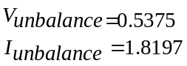 %
Leading Open Wye-Delta Solution

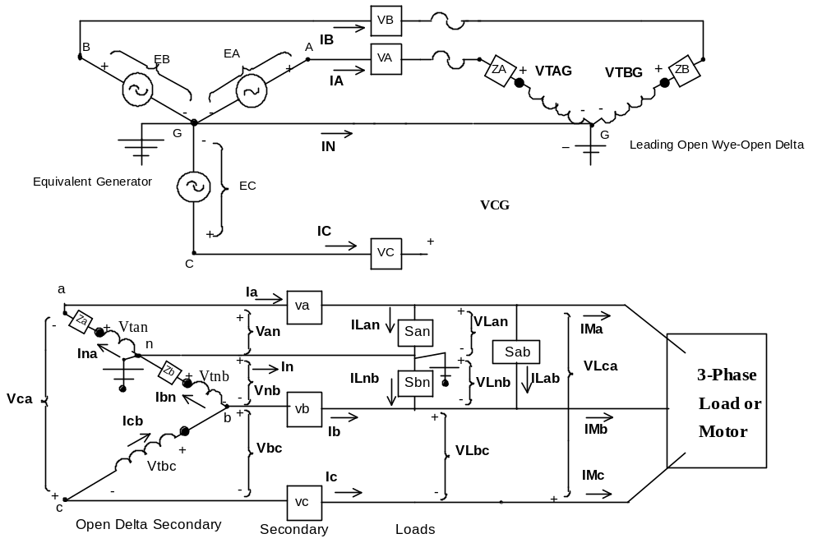

Source LG Voltages Source LL Voltages

V V

Primary Line Voltage Drops End of Line LG Voltages

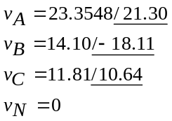 V 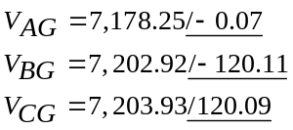 V

Transformer Primary LN Voltages Transformer Primary LL Voltages

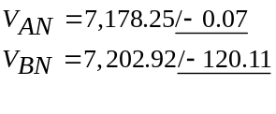 V 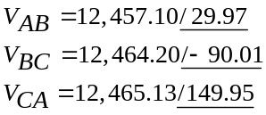 V

Neutral to Ground Voltage at Transformer Primary

V

Primary Windings Ideal Voltages Primary Line, Neutral and Ground Currents

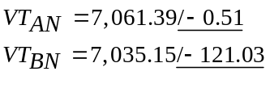 V 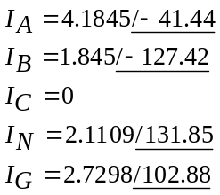 A

Transformer Secondary Windings Ideal Voltages Transformer Secondary Terminal Voltages

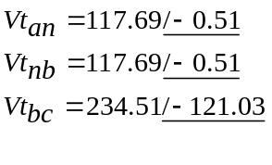 A 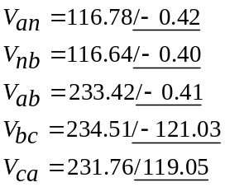 V

Transformer Secondary Winding Currents Secondary Line, Neutral and Ground Currents

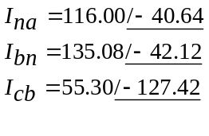 A 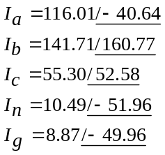 A

Secondary Line Voltage Drops Single-Phase Load Voltages

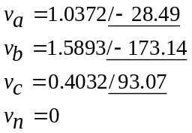 V 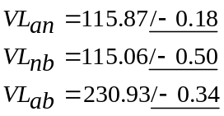 V

Single-Phase Load Currents Single-Phase Complex Powers
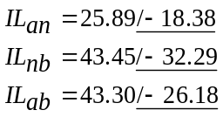 A kVA

Motor LL Voltages Motor Line Currents

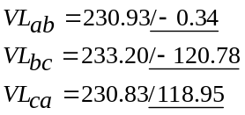 V 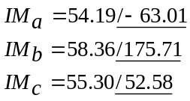 A

Transformer Operating kVAs

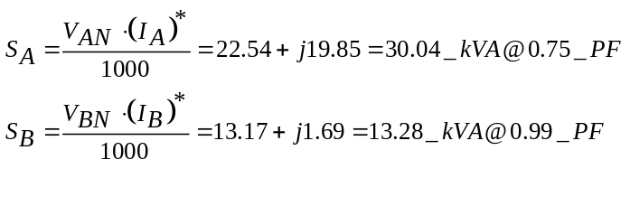

INDUCTION MOTOR ANALYSIS

Stotor Input Complex Power Rotor Currents

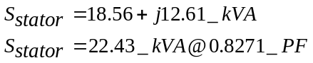 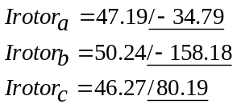 A
Losses Converted Shaft Power

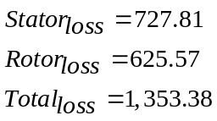 W 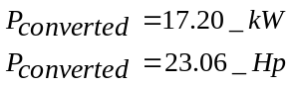 kW

NEMA Unbalances

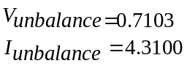 %

Lagging Open Wye-Delta Solution

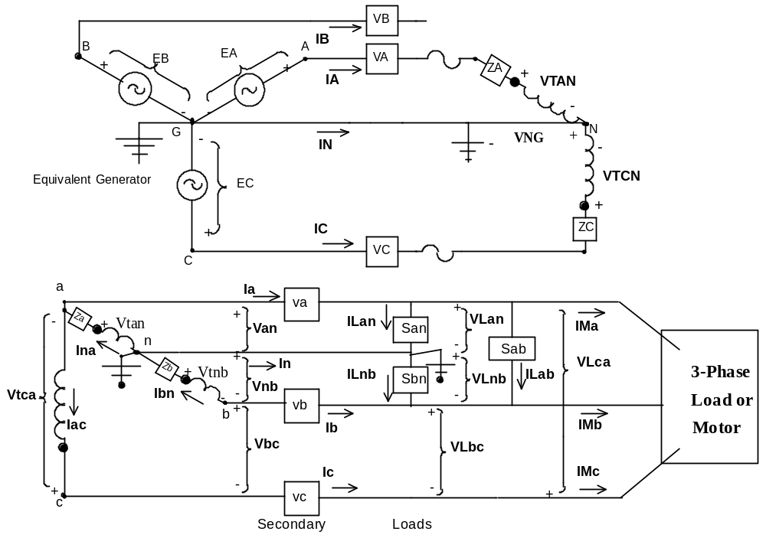

Source LG Voltages Source LL Voltages

V V

Primary Line Voltage Drops End of Line LG Voltages

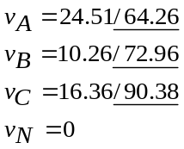 V 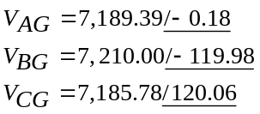 V

Transformer Primary LN Voltages Transformer Primary LL Voltages

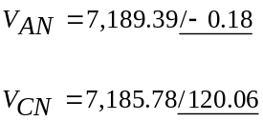 V 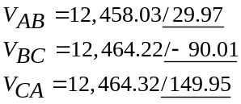V

Neutral to Ground Voltage at Transformer Primary

V

Primary Windings Ideal Voltages Primary Line, Neutral and Ground Currents

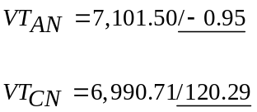 V 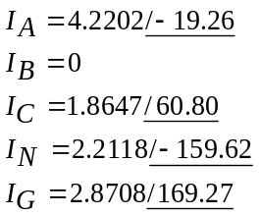 A

Transformer Secondary Windings Ideal Voltages Transformer Secondary Terminal Voltages

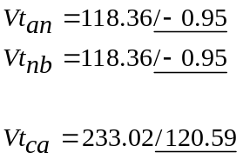 A 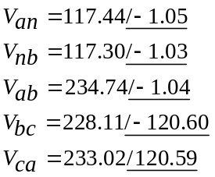 V

Transformer Secondary Winding Currents Secondary Line, Neutral and Ground Currents

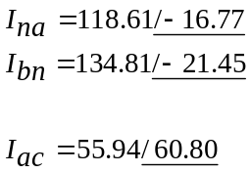 A 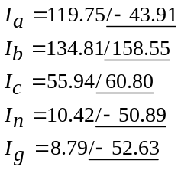 A

Secondary Line Voltage Drops Single-Phase Load Voltages

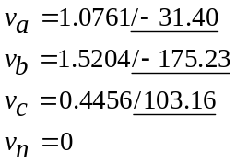 V 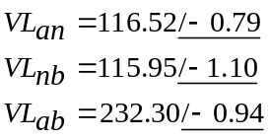 V

Single-Phase Load Currents Single-Phase Complex Powers

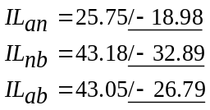 A kVA

Motor LL Voltages Motor Line Currents

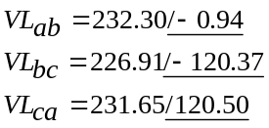 V 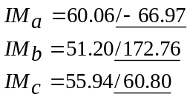 A

Transformer Operating kVAs

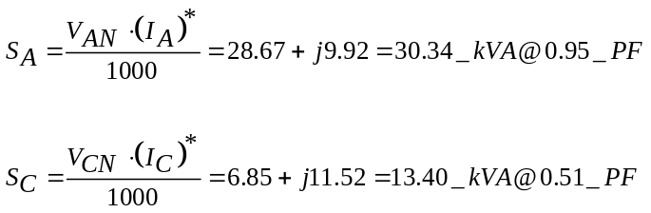

INDUCTION MOTOR ANALYSIS

Stotor Input Complex Power Rotor Currents

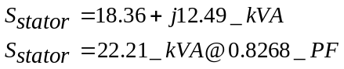 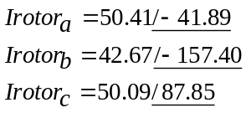 A

Losses Converted Shaft Power

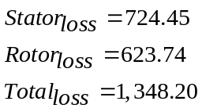 W 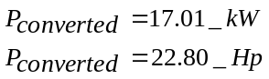 kW

NEMA Unbalances

 

